

FACULTY OF TECHNOLOGY AND ENGINEERING
DEVANG PATEL INSTITUTE OF ADVANCE TECHNOLOGY AND RESEARCH
DEPARTMENT OF INFORMATION TECHNOLOGY

A.Y. 2026-27 [ODD]

LAB MANUAL

CSUC201: DSA


Practical 2: Linear and Binary Search: Iterative and Recursive Approaches

Problem 1
A security guard at a parking lot checks vehicles one by one from the entrance to find a car with a specific license plate. Sometimes he starts from the entrance, sometimes he calls a helper who starts from where the guard left off. Given a list of license plates and a target plate, implement both approaches — one that checks plates one by one from the start, and one where the function calls itself to continue checking — and report the position of the target plate if found.
Describe the approach you used. What happens in your solution if the target plate appears more than once in the list? Does it find the first occurrence, the last, or just any one?

Code- https://github.com/krishangpatel16-dotcom/FDSA-Batch-B/tree/main/Practical%202
Output-
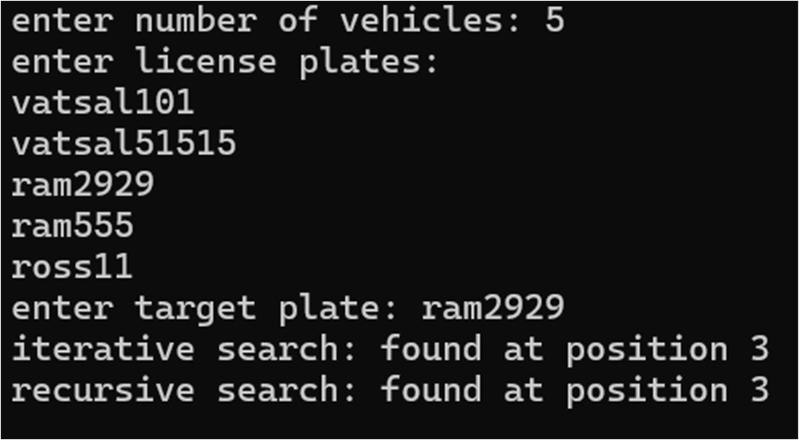
Problem faced-
-In this problem, I was confused about where the second guard should start checking the number plates, but I solved it by passing the current position to the recursive function so it continued searching from where the previous check ended.
Conclusion: Both iterative and recursive approaches check the plates one by one and return the position of the first occurrence of the target plate; if it appears multiple times, the search stops as soon as the first match is found.

Problem 2
A librarian maintains a sorted catalog of book codes and needs to locate a specific code quickly. Instead of going through every book, she opens the catalog to the middle, checks whether the target is to the left or right, and repeats. Given a sorted list of book codes and a target code, implement both approaches — one using a loop and one where the function calls itself — and report the position of the target code.
Describe the approach you used. What is the one condition your input must satisfy for this approach to work correctly? What would go wrong if that condition was not met?
Code- https://github.com/krishangpatel16-dotcom/FDSA-Batch-B/tree/main/Practical%202
Output-
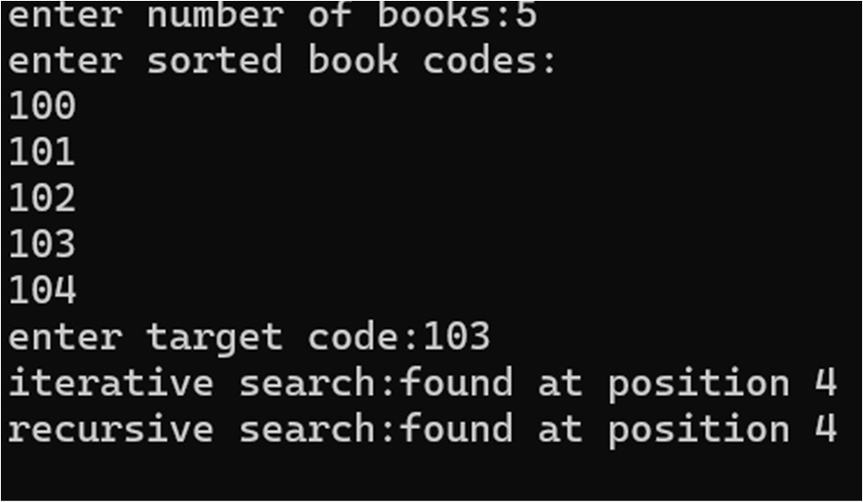
Problem faced-
-In this problem, I faced difficulty understanding how binary search reduces the search space, but I overcame it by updating the low and high values after each comparison.
Conclusion: Both iterative and recursive binary search efficiently find the target by repeatedly dividing the search range in half, but the catalog must be sorted; otherwise, deciding whether to search left or right would be incorrect and the target might not be found.

